**Week 11**

Creating grafana

gcloud container clusters list

gcloud container clusters create my-cluster --zone us-central1-a

gcloud container clusters get-credentials my-cluster --zone us-central1-a

kubectl get nodes

kubectl get ns

kubectl create namespace monitoring

kubectl get ns

kubectl get secrets -n monitoring

helm repo add prometheus-community <https://prometheus-community.github.io/helm-charts>

helm repo update

**helm install kube-prometheus-stack prometheus-community/kube-prometheus-stack \**

**-n monitoring --create-namespace**

**kubectl get secret kube-prometheus-stack-grafana -n monitoring \**

**-o jsonpath="{.data.admin-password}" | base64 --decode ; echo**

helm install kube-prometheus-stack prometheus-community/kube-prometheus-stack -n monitoring --create-namespace

kubectl get secret kube-prometheus-stack-grafana -n monitoring -o jsonpath="{.data.admin-password}" | base64 --decode ; echo

kubectl port-forward svc/kube-prometheus-stack-grafana -n monitoring 3001:80

**admin**

**prom-operator**

**week 12**

kubectl get pods -n monitoring

kubectl get svc -n monitoring

Access prometheus and port forwarding

kubectl port-forward svc/prometheus-kube-prometheus-prometheus 9090:9090 -n monitoring

**week 9**

Create the pods

Kubectl run --image tomcat webserver

To get the list of pods along with ip address and which node the pod is running

Kubectl get pods -o wide

Create pd-df1.yaml

Vim pd-df1.yaml

apiVersion: v1

kind: Pod

metadata:

name: jenkins-pod

spec:

containers:

- name: myjenkins

image: jenkins/jenkins

ports:

- containerPort: 8080

hostPort: 8080

for accessing the application u need to open the port

How to open the port

gcloud compute firewall-rules create rule2 --allow tcp:8080

Kubectl create -f pd-df1.yaml

Kubectl get pods -o wide

Kubectl get nodes -o wide

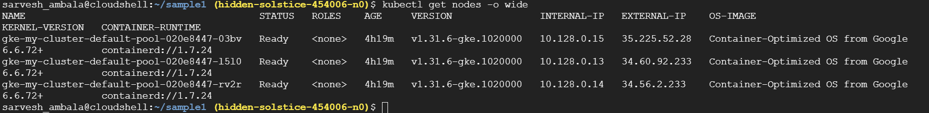

How can we access the pod

Take the external ip add the port no 8080

Open the browser paste ipaddress:8080

Now u can able to see the Jenkins